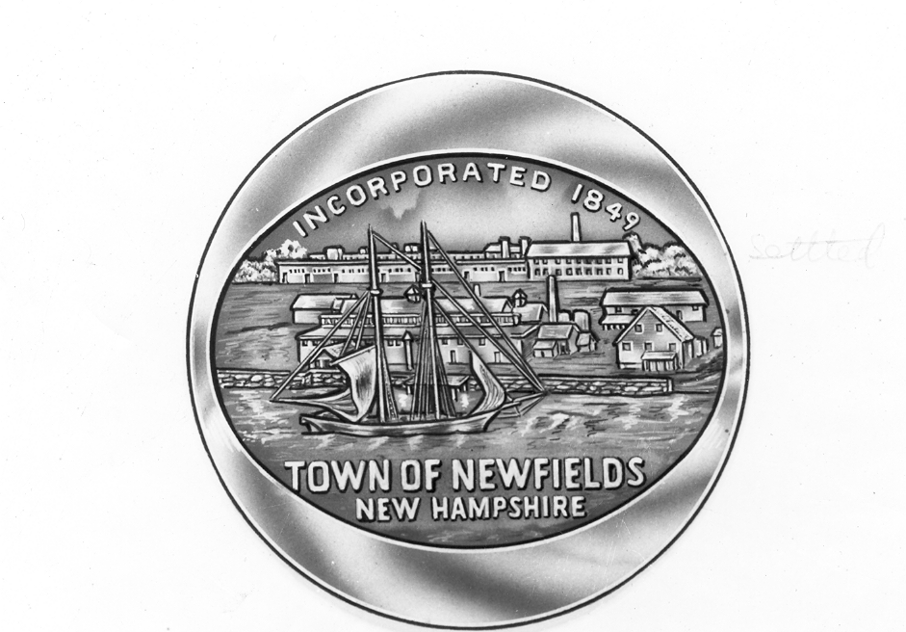
Town of Newfields
65 Main Street
Newfields NH 03856
www.newfieldsnh.gov
603-772-5070-phone
603-772-9004-fax

TOWN OF NEWFIELDS, NH
ZONING BOARD OF ADJUSTMENT
AGENDA APRIL 24, 2024

1. Call to order 7pm

2. Case# 24-03-27-01
A variance application submitted by Hoefle, Phoenix, Gormley & Roberts PLLC, on behalf of applicant Jason Ward, 11 Swamscott St, Newfields, seeks relief from Article III, Schedule 3.4.2-Schedule 2 to allow a 0' side yard setback where 25' is required, a 9.15' front yard setback where 25' is required, and a 19.15' front yard setback where 25' is required, and relief from Article IV Section 4.9 to allow 29.7% building coverage where 25% is permitted. The applicant proposes to construct a 24 x 24 two story garage and seeks approval for an existing nonconforming sugar shack. The property Is located in the Residential Village District, known as Map 102 Lot 26.

3. Other business

